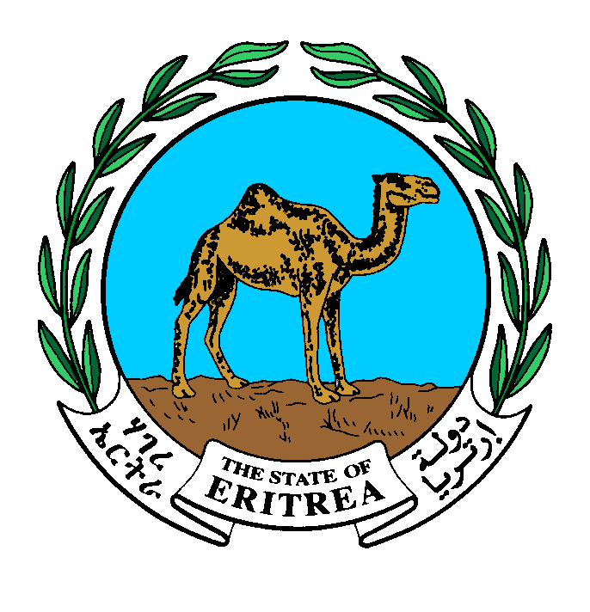

Empowered lives
Resilient nations

UNDP Eritrea

2014 Annual Work Plan

Project name | Amount
Sustainable Land Management Pilot Project | 678,280.00

Dr. Giorgis Teklemikael  Minister  Ministry of National Development | Ms. Christine N. Umutoni  Resident Representative  UNDP Eritrea | Mr. Tesfai Gebreselassie  Minister  Ministry of Land, water and Environment
Signature: | Signature: | Signature:
Date: | Date: | Date:

Annual Work Plan 2014

Country: Eritrea

SPCF Outcome: Eritrea is on track towards the achievement of MDG targets for environmental sustainability (MDG7)
Expected Outcome (SRF): Support development and protection of the environment and natural resources.

Expected Outcome Indicator: Number of households with improved land use management system and level of increased production

Expected Outputs: Enabling conditions for sustainable land management established

Coordinating Authority: Ministry of National Development

Implementing partners: Ministry of Land, Water and Environment
The proposed project will provide an enabling environment for sustainable land management through four outcomes that overcome the barriers, and are in line with the objectives of the GEF Strategic Investment Program for SLM in Sub-Saharan Africa (SIP) and SPCF 2013-16. These include i) development and testing of SLM models in pilot areas; the Serejeka sub-zoba of the Maekel Zoba, one of Eritrea’s major regions. A significant part of the model will be the testing of application of the 1994 Land Proclamation provisions, as an incentive to SLM; ii) support to the establishment of sustainable knowledge management systems to provide quality and timely information for decision making, help disseminate lessons; iii) establish a critical mass of skilled and empowered SLM actors in Eritrea; and iv). establish a natural resource management monitoring systems by which lessons and experience of Eritrea are shared widely.

Programme period: 2013 - 2016
Programme Component: Environment and Sustainable development.
Project Title: Sustainable Land Management Pilot Project
Project Code: 00063220
Project Duration: 2013- 2015
Estimated annualized budget: 678,280

Allocated resources: _______
- Government _______
- Regular (UNDP) 450,000
- Other:
-Donor (GEF) 228,280
-Donor _________
-Donor _________
Unfunded budget: _______

Agreed by Government Coordinating Body (MND):
________________________________________________________________________________

Agreed by Implementing Partner: (Zoba Maekel Adminstrative Region)
________________________________________________________________________________

Agreed by UNDP:
________________________________________________________________________________

Work Plan
Year: 2014

EXPECTED CP OUTPUTS  and indicators including annual targets | PLANNED ACTIVITIES  List all activities including M&E to be undertaken during the year towards stated CP outputs | TIMEFRAME |  |  |  | RESPONSIBLE PARTY | PLANNED BUDGET
 |  | Q1 | Q2 | Q3 | Q4 |  | Source of Funds | Budget Description | Amount  US
Sustainable models for agriculture, grazing lands and forested lands developed and piloted in more than 28 villages  Targets:  140,000 hactares of land under pilot scheme  Indicators:  No. of villages and area of land covered | 1.1.1 : In participatory manner develop “SLM work plans” with pilot communities identified during project preparation; confirm local interest & operationalise project leadership, management & implementation arrangements  1.1.2: Undertake needs assessment to identify capacity (incl. technical, financial, policy) & training needs for SLM in the pilot communities  1.1.3: Together with expert organizations (e.g. MoA, Agricultural Colleges, international collaborators) develop and subsequently implement Farmers Action Research & Training programmes relevant to SLM in the CHZ  1.1.4: Strengthen regional & national level expert support mechanisms & institutions to provide relevant & appropriate research and management information, including on service delivery  1.1.5 Develop relevant extension service response measures & establish an effective working link between client (farmer) and provider (primarily government extension); explore opportunities of promoting private & business investments (national/international) in support of SLM |  | X | X | X | Ministry of Agriculture (Zoba Maekel) | 62000-GEF  04000-UNDP | 71200 Consultant  74500 Miscellaneous expenses  75100 Facilities and Admin  72100 Contractual services  74500 Miscellaneous expenses | 10,000  10,000  10,000  20,000  10,000
1.2: Systems of incentives & penalties are developed & applied at multiple levels to further the adoption of SLM practices | 1.2.1: Identify appropriate incentive and disincentive measures for SLM and develop key support systems e.g. relevant regulations and penalties; commission in-depth study in support of this activity  1.2.3 Collect best practices from Eritrea and other areas around the world that demonstrate how to successfully establish such systems and disseminate widely; integrated the notion of payment for ecosystem services, where appropriate |  | X | X | X | Ministry of Agriculture (Zoba Maekel) |  |  | 100,000  17,000
 | 1.2.5 . Facilitate the successful testing of developed incentive measures and integration into national pro-SLM policies and regulations  1.3.1.: Operationalise consultations and awareness campaign on 1994 Land proclamation as stipulated under output 1.3 |  | X | X | X |  |  |  | 10,000  50,000

1.4. Community-based, village-level land use planning and land redistribution methodologies are developed and piloted in 28 villages | 1.4.6: Document processes, implement M&E programme and synthesize key lessons learnt to feed into the development of local level LUP and land redistribution best practice tools, which can be adapted and replicated elsewhere |  | X | X | X |  |  |  | 10,000
1.5: : Alternative income generating options piloted and linked to markets in 28 villages  Output 2.1: Knowledge management (KM) network formed of institutions and projects concerned with  Output 2.2: Capacity for research on SLM supported;  Output 2.3: SLM M&E established and linked to SLM country program and SIP;  Output 2.4: SLM is mainstreamed into relevant programmes, policies & legislation, & is integrated throughout development planning & budgeting processes.  Output 3.1 Training programmes on SLM for different groups (farmers, land managers, technical officers) available and training conducted (with a focus on pilot site).  Output 3.2: Extension package updated with SLM best practice provided and other relevant materials developed through KCAS successfully delivered to key target groups and intended impacts on awareness and skills base achieved.  Output 3.3: Service providers (incl. e.g. agricultural input suppliers, extension services, financial service providers) strengthened to provide effective and relevant SLM support to community level.  Output 3.4: SLM actions are climate change proof, mainstreaming adaptation and mitigation | 1.5.1 Undertake/commission an expert scoping study that establishes feasibility and options for alternative income generation in pilot area, with potentially wider reaching trading linkages  1.5.2:  Use scoping study for public awareness activities and as venture point for discussion of the development of alternative income generating activities with target groups and key stakeholders  1.5.3 Based on initial experiences develop strategy of how to promote alternative income generating activities; link to SLM programme and other relevant country strategies and plans  1.5.4:  Support development of alternative income generating options amongst pilot community members through facilitating technical support and, as appropriate, financial start up (e.g. loans, micro credit schemes, proposal development, SME incentives national/international)  2.1.1 Establish an KM network based on stakeholders and interested parties identified in the project preparation phase, and partially reflected in the stakeholder involvement plan (Section IV); build on existing Sustainable Land Management Forum (SLUF) facilitated by TICD; hold inception meeting and operationalise  2.1.3 Establish relevant delivery mechanism and implement KCAS i.e. in a form of a SLM information management systems at the level of the Zoba Maekel, with access beyond; M&E of implementation  2.2.2 Develop local level research capacity through implementing Farmers’ Action Research programme addressing key SLM needs at pilot sites, including local level resource tracking/ monitoring/ SLM M&E activities leading to adaptive management  2.2.3Train extension personnel from both government and non-government sectors in research extension skills and targeted SLM related research skills  2.2.4 Develop a SLM trainee programme/course for (agricultural) colleges and, if appropriate, University  2.2.5 Facilitate availability of research information and research collaboration including with international Centers of Excellence/research institutions (e.g. research traineeships, exchange visits, internet based information portal)  - Develop SLM M&E methodology in pilot area (linked to output 2.2), taking into consideration bio-physical and socio-economic indicators and developing performance targets that clearly illustrate achievements made on investments  2.3.2 Establish overall SLM baseline for this project during inception phase, including the confirmation of the set indicators and performance targets  2.4.1 As part of the Knowledge, Communication and Awareness Strategy (KCAS) (output 2.1) develop section that particularly targets planners, policy and high-level decision makers at sub-zoba, zoba and national level  2.4.4 Commission a discussion paper that illustrates how SLM could be effectively integrated into the new national land use policy (table e.g. at policy roundtable see activity 2.4.3 and during other relevant events)  2.4.5 Develop and implement action plan of how to support the mainstreaming of SLM in the new land use policy  - Develop targeted capacity support strategy and action plan (CSSAP)  - Implement CSSAP during project duration and, through a long-term mainstreaming strategy, ensure that activities are integrated into institutional programmes and continue beyond project horizon  3.2.2 In support of output 2.4 develop material targeted to senior decision-makers; implement pilot site visits to community to establish a direct exchange and debate on SLM between the farmers and senior policy and decision-makers  - Establish platform for interactive dialogue between service providers and clients (communities/farmers/land managers) and amongst service providers themselves to discuss client needs and coordinate service delivery where relevant  - Strengthen input suppliers to provide SLM technologies (seeds, tools, etc.) through creating an enabling environment at national level (e.g. promote accessibility to imported goods where necessary; support establishment of needed market conditions)  - Develop and implement a strategy for adapting SLM to climate change in Eritrea, linked to NAPA and related CCA projects  - Develop project CCA plan and mainstream CC throughout this project, as relevant |  | X | X | X |  |  |  | 10,000  10,000  10,000  100,000  30,000  5,000  27,000  20,000  15,000  32,280  10,000  30,000  12,000  15,000  10,000  10,000  15,000  20,000  15,000  5,000  20,000  10,000
 | Total 678,280

